EXPERIMENT 27
ITA0305-Mobile Computing For App Development

27.Use Figma to create an interactive presentation comparing the Core Video framework in iOS and the multimedia framework in Android.

Aim: Create an interactive presentation comparing the Core Video framework in iOS and Android using Figma

Procedure:

1.Define Presentation Structure
2.Create a Figma Project
3.Design Visual Elements
4.Make it Interactive
5.Add Annotations and Explanations
6.Incorporate Multimedia
7.Storyboard Animation
8.Test the Prototype
9.Collaborate and Gather Feedback
10.Finalize and Share

Design:

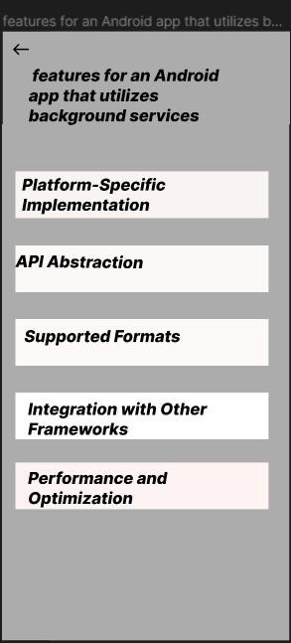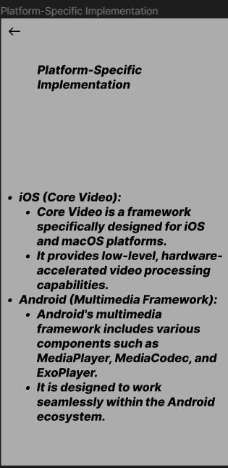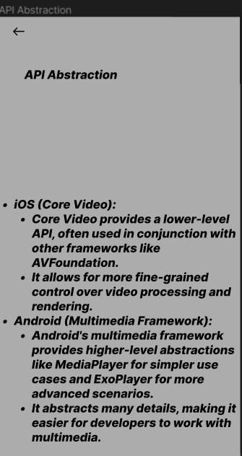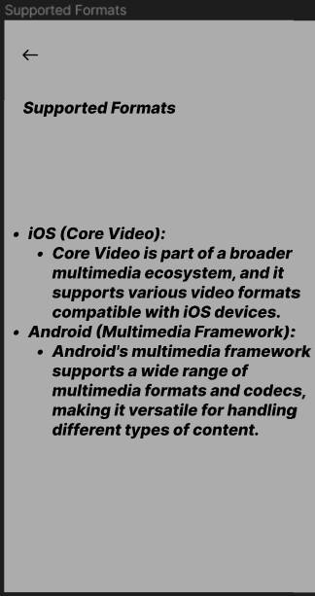

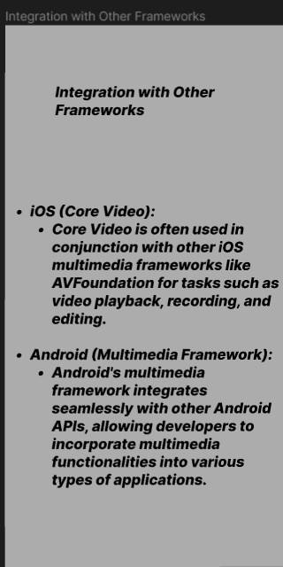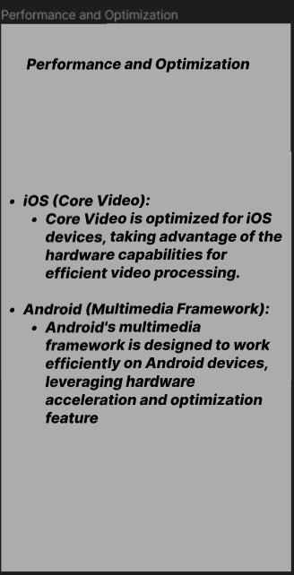

Prototype:
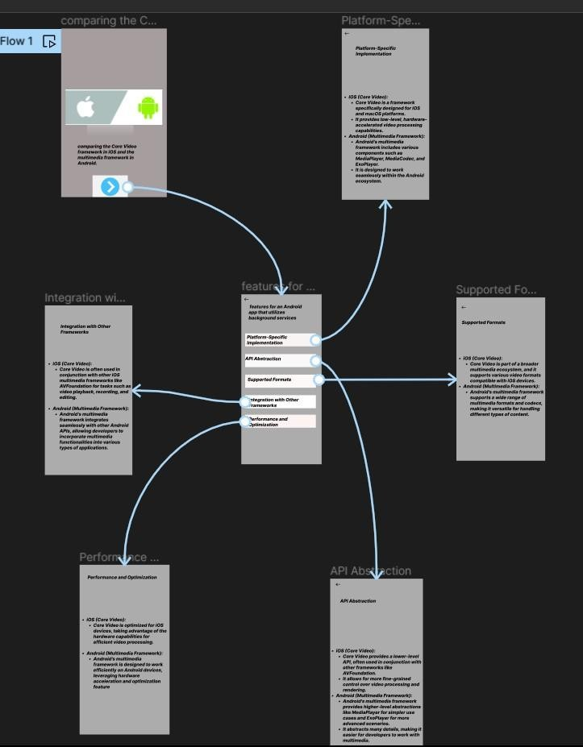
Result: Hencean interactive presentation comparing the Core Video framework in iOS and Android using Figma have been created successfully .

